Quality Improvement Template (PDSA)
Practice name: |  | Start Date:
Practice name: |  | End Date:
CQI Activity Team:
Activity Focus:
How will you measure the change? | Start Measure: | Desired End Measure:
NOTE: This resource has been adapted from information developed by WA Primary Health Alliance.
PLAN - | Describe the idea | What, who, when, where | Make predictions | Define data to be collected.
DO - | Carry out the plan | Document progress, any errors or barriers | Adopt, adapt, abandon as required.
STUDY - | Analyse the data | Compare the data to your predictions | Summarise & reflect on the lessons learnt.
ACT - | What next? | Implement change or try something new | What idea will you test next?

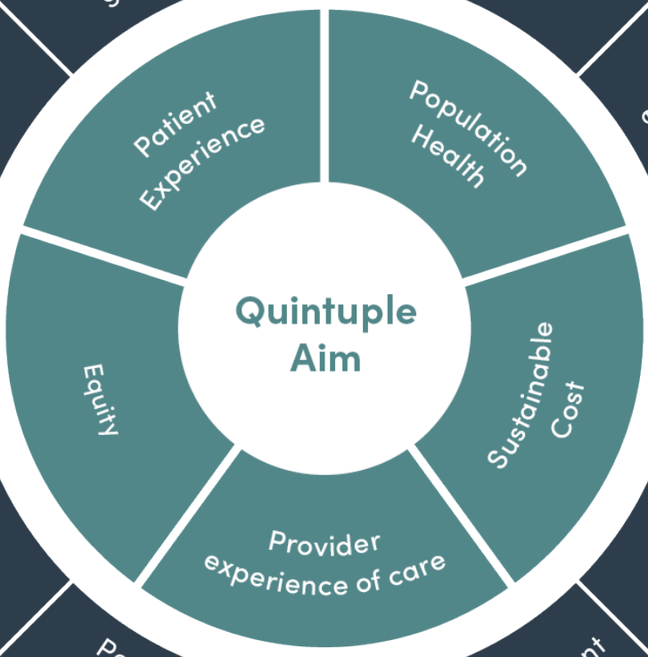 | The Quintuple Aim drives health system performance, by requiring healthcare organisations to simultaneously pursue five dimensions of performance:  - improving the health of populations  - enhancing the patient experience of care  - sustainable cost  - health equity  - improving the work life of healthcare providers.

Scan me for more information on Continuous Quality Improvement!
PIP QI has 10 Quality Improvement measures:
- diabetes with a current hba1c result
- smoking status
- weight classification
- 65+ and influenza immunisation
- diabetes and influenza immunisation
- COPD and influenzas immunisation
- alcohol consumption status
- risk factors enable CVD assessment
- cervical screening
- diabetes & blood pressure.

