Practice Initiated MyMedicare Registration Form Instructions
Disclaimer: This activity is an example only and may not suit your practice or care setting. Discuss the approach to registration with your general practice team determine the best approach to suit your needs.

To streamline the process of registering your Residential Aged Care Home (RACH) Patients for MyMedicare you may choose to provide prefilled MyMedicare Registration forms for patients or their decision maker to sign.

The following instructions detail how to produce prefilled MyMedicare registration forms in bulk.

- Using your clinical software, get a list of RACH patients that each doctor visits. You can get this information from a search of the patients who reside in each RACH if you have this information recorded in your clinical software. If not, you could search by the RACH address or by MBS item numbers that are exclusive to RACH’s (eg 90020, 90035, 90043) to get a list of residents.

- When you run this search, you want to include the following information in the report:
  - Patient Family Name
  - First Given Name
  - Second Given Name
  - Date of Birth
  - Medicare/DVA Number
  - Medicare IRN
  - Name of preferred GP

- Export the report to an excel spreadsheet and remove columns as needed. You should end up with a worksheet that looks something like this. Tip – for best results you will need one worksheet per doctor.
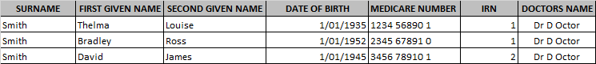

- Open the MyMedicare patient registration form MS Word Version form in Microsoft Word.

- In MS Word go to the Mailings Tab and Select Start Mail Merge. Select Step-by-Step Mail Merge Wizard.

- There are 6 steps to the Step-by-Step Mail Merge Wizard:
  - Step 1 – Select letters, and the select ‘Next: Starting document’ down the bottom of the column on the right-hand side of the page
  - Step 2 – Select use current document. Now select ‘Next: Select recipients’ from the bottom of the column on the right-hand side of the page
  - Step 3 – Select Use an existing List. Use the browse tab to open the spreadsheet of RACH patients you did earlier and select ok twice. Now select "Next: Write your Letter" at the bottom right of the screen
  - Step 4 – We now want to link the spreadsheet fields to the word document. Do this by clicking your cursor in the Family name box on the MyMedicare Registration Form, and then select ‘more items’ from the right-hand column. Select the relevant field from the list by double clicking on it. Select close to get back to your document. You will need to repeat this process for all other fields. You will then need to type in your practice name and address – this will appear in all the documents once the mail merge is completed. Now select "Next: Preview your letter" at the bottom right of the screen. Your form should look like this:
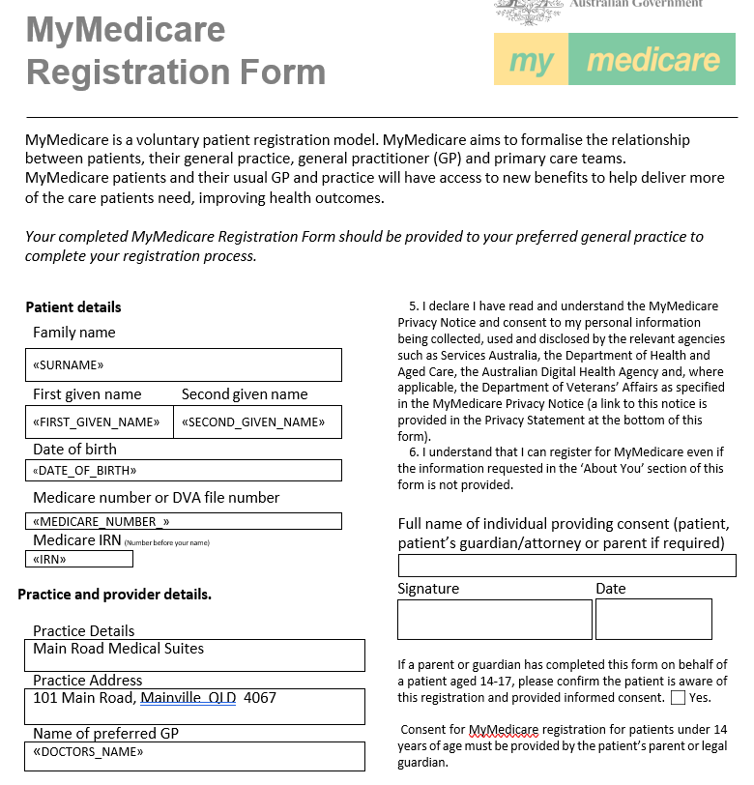

  - Step 5 – Preview your letters. Your forms should now look like the image below. If there are any problems, go back to step 4 and correct the issue. Now select "Next: Complete the Merge" at the bottom of the screen.
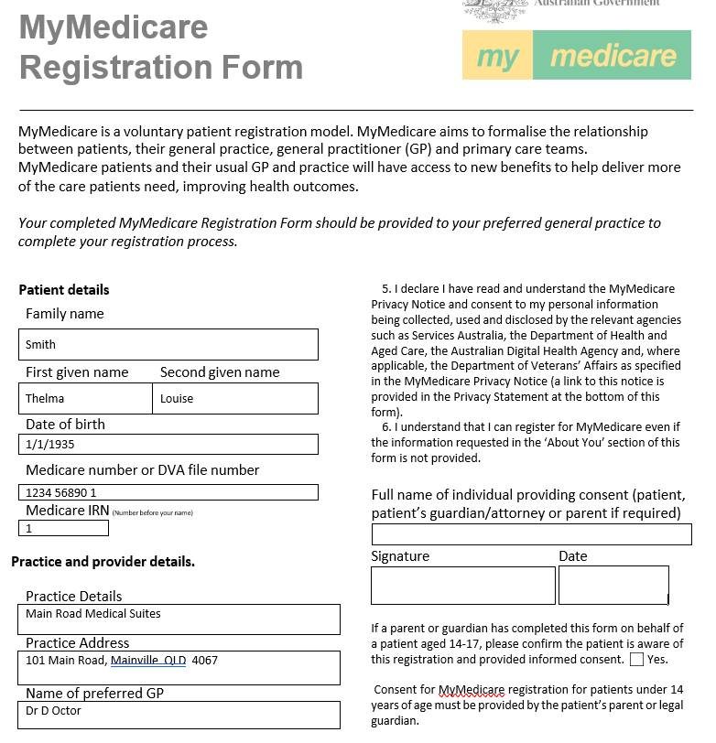

  - Step 6 – Select edit individual letters and click on all and select ok. This allows you to check all the forms before you send them to the printer. All forms will now be in one document.

- Print the forms (you can also save them, and attach them to an email them if you want to)

- Once the forms are printed collate them with a covering letter for the Residential Aged Care Home (see attached document).

- When you deliver them to the RACH make sure you take the time to explain what the MyMedicare scheme is about and why these registration forms are important. Work in with RACH staff and within the RACH timelines wherever possible. Patients can be registered up until 30 September to be included in this first GPACI calculation.

- When the forms are returned enter them into MyMedicare and enrol patients in the GPACI. Make sure you record in your clinical software that you have recorded them, what date and who is their preferred doctor.

