Micro-Activity 1: Whole-of-Practice Brainstorm

What is PHASES?
PHASES stands for Preventing Heart Attacks and Stroke Events through Surveillance. It’s a state-wide program in Queensland and focuses on:
· Improving early identification of patients at risk of cardiovascular disease (CVD)
· Strengthening data quality and recording
· Supporting a whole-of-practice approach to care
· Building sustainable quality improvement over time: Start small → Build capability

What are we trying to do?
We are starting with small, practical steps that can be adopted by your practice.
This activity helps your team:
- Look at how you currently manage heart health
- See what is working well
- Choose one small area to improve

How to do this activity?
This is a short team brainstorming activity involving all staff. The aim is to:
- Reflect on your current approach to CVD prevention
- Identify what’s working well
- Highlight one area to improve
Note: Please feel free to take photos during this activity and share our experience as a case study with us. Reach out for more information.
Step 1 – Watch the short webinar on a whole-of-practice approach. You can fast-forward the first 10minutes as it is an introduction on PHASES program. There is a short quiz below that you can do after watching this webinar (optional). Scan this QR code to access the video and your GPs can self-claim CPD points.

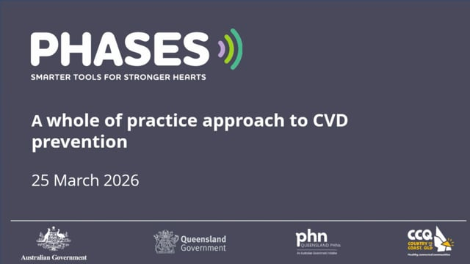
Step 2 – Discuss the following as a team (10–15 mins)
Use the worksheet to guide your discussion:
- What?
What are we doing well? What could we improve?
- So what?
Why does this matter for our patients and our practice?
- Now what?
What is ONE thing we should improve first?
You can complete this activity in a way that best suits your practice. For example, you may choose to discuss it during a staff meeting, run a short team discussion in person or via Teams, or place the worksheet and instructions in a common area (e.g. notice board or staff room) for team members to contribute individually over time.
The aim is to involve as many team members as possible and capture a range of perspectives across the practice.

Step 3 – Write it down
- Fill in the worksheets
- Keep it simple
- Come up with one area of improvement as a team.

Step 4 – Send it to us
- Take a photo or scan OR complete it electronically
- Send to practicesupport@brisbanenorthphn.org.au

Post Webinar Short Quiz (Optional)

1. True or False
CVD risk management is primarily the responsibility of the GP.

2. Which of the following best describes a whole-of-team approach?
a) Only GPs manage CVD risk
b) Tasks are shared across clinical and non-clinical staff
c) Only nurses manage prevention
d) Patients manage their own care

3. Which team member can support identifying eligible patients for CVD risk assessment?
a) GP
b) Nurse
c) Reception/Admin
d) All of the above

4. What is one common barrier to effective CVD risk management in general practice?
a) Too much time available
b) Clear workflows already in place
c) Time and workflow constraints
d) Too many completed assessments

Answers:
- False
- B
- D
- C

Worksheet 1: What
Ask:
- Are eligible patients being identified consistently?
- Where are the gaps in recording, recall, or follow-up?
- Are there groups of patients missing out?
- Is the issue clinical, operational, or both?
- What data our practice already collects that may help us understand CVD risk management?
What are we doing well in managing CVD? | What could we improve?

Worksheet 2: So what?
Why does this matter for our patients?

Worksheet 3: Now What?
What is ONE thing we should do to improve our management of CVD first? | (take a vote after team members shared their views below)

