Continuous Quality Improvement Practice Guide

Diabetes

April 2025 – August 2025

Why Diabetes Care?
Diabetes in Australia: A Growing Challenge

Diabetes is one of Australia’s fastest-growing health concerns, affecting both individuals and the broader healthcare system. As of 2022, around 1.3 million Australians—or 5.3% of the population—are living with some form of diabetes (ABS, 2022). The majority (85–90%) have type 2 diabetes, which is largely preventable (AIHW, 2023).

In Queensland, the prevalence has surged from 3.2% in 2001 to 5.1% in 2022, reflecting national trends. Men are particularly at risk, with 6.4% affected compared to 4.1% of women (ABS, 2022). This steady rise signals a growing public health challenge.

The Financial and Human Cost

Diabetes isn’t just a clinical issue; it’s an economic one. In 2020–21, Australia spent $3.4 billion on diabetes care, accounting for 2.3% of all disease-related health expenditure (AIHW, 2022). Beyond direct healthcare costs, missed check-ups, delayed interventions, and preventable complications related to type 2 diabetes are estimated to cost an additional $2.3 billion annually (Diabetes Australia, 2022).

The human toll is even more profound. Further complications from diabetes include heart disease, kidney failure, blindness, and amputations are common, significantly reducing quality of life.

Opportunities for Improvement

Despite the challenges, there’s strong evidence that targeted interventions can reverse these trends:
- Early screening and lifestyle changes can reduce the risk of developing type 2 diabetes by up to 58% in high-risk groups (WHO; AIHW, 2023).
- Better data collection and integration—through tools like Primary Sense—can identify care gaps, improve treatment planning, and lead to better patient outcomes (AIHW, 2023).
- Good glycaemic control (measured by HbA1c) reduces the risk of complications like eye, kidney, and nerve damage by 25% or more (UKPDS, 1998; cited by AIHW, 2022).
- Team-based care, including routine GP check-ups and allied health support (e.g., dietitians), reduces hospitalisations and improves self-management.

Why This Project?

Given the rising prevalence of diabetes, its significant health and economic impacts, and the proven benefits of early intervention, our project has three focus areas:

- Improve Identification and Prevention of Diabetes
By proactively identifying at-risk individuals and implementing early interventions, we can reduce the impact of diabetes and its complications.
- Enhance Data Quality
Accurate, comprehensive data is the foundation of effective diabetes management. High-quality data helps us monitor trends, identify gaps, and tailor care to improve patient outcomes.
- Improve Diabetes Care and Health Outcomes
Optimising clinical management, including regular HbA1c monitoring, complication screening, and coordinated care, will improve health outcomes and reduce preventable hospitalisations.

Continuous Quality Improvement (CQI) Process
Continuous Quality Improvement (CQI) activities are actions designed to help practices work better, safer, and smarter. Ideally, CQI activities are small, incremental adjustments to existing processes that will result in long-term changes that add value to your practice.
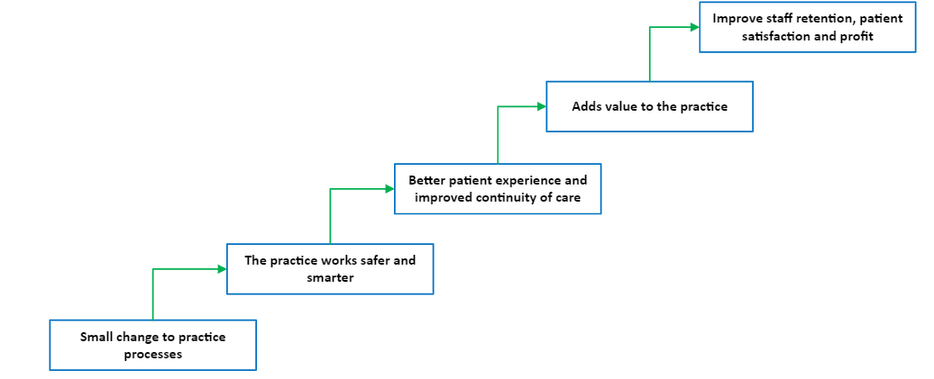

Practice participation
Practices will be encouraged to complete between two and four CQI activities. They may choose from the activities outlined in the table below or they may or develop practice-specific activities designed to improve outcomes for their patient cohort. The Practice Development Matrix can help practices to develop these practice-specific activities.

Practices that complete at least 2 CQI activities and submit the paperwork to Brisbane North PHN will be provided access to the CDM Plus portal from 1 June 2025 – 30 June 2026.

The CDM Plus portal allows practices to access 25% discount on selected training services and products such as workshops, training sessions, and health promotion products as well as access to a range of online resources including templates, Webinars and information Sessions.

CDM Plus resources are continually updated to reflect MBS, MyMedicare and Clinical Software changes and cover a range of topics including:

- Asthma
- CVD
- Diabetes30th May
- Kidney Disease
- Cervical cancer
- COPD
- Health Assessments (Including 715)
- Mental Health
- Osteoporosis
- Skin Cancer
- COVID/ Immunization

The process
- To participate, complete Part 1 of the Diabetes Continuous Quality Improvement Plan and submit it to practicesupport@brisbanenorthphn.org.au by 30 May 2025. This document will outline the:
  - Diabetes care goals you want to achieve
  - Activities you will implement to achieve these goals
  - Timelines you are working to
  - How you are going to measure your progress.

Practices can choose between two and four Continuous Quality Improvement (CQI) activities from the list below (Table 1 - Focus Areas and suggested CQI activities). You can also develop practice-specific activities you think will improve the Diabetes Prevention and Care for your patient cohort. The Practice Development Matrix can help you to develop these activities

- Brisbane North PHN will get back to let you know if you have been approved to participate in this CQI Activity.

- Work on your proposed activities with the support of your QI&D Engagement Officer between April and August 2025.

- When you have completed your activities, complete Part 2 of the Diabetes Continuous Quality Improvement Plan and submit it to practicesupport@brisbanenorthphn.org.au by 30 August 2025.

- We will send you your login details for the CDM Plus portal. You will have full access to the CDM Portal from 1 June 2025 – 30 June 2026.

Things to note
- The CDM Plus Portal access is for undertaking the CQI activities, tracking and reporting on their progress. Access to this corporate membership is not subject to all activities having had a positive outcome (or even the intended outcome).

Suggested CQI Activities for Practices
Possible activities for practices to undertake are outline below. Which activities they choose will be determined by their current practice experience and situation, their patient populations and their practice goals and objectives. Practices may also select other activities tailored to improve the outcomes of their patient cohort and practice needs. The Practice Development Matrix can help with devising practice-specific activities.
If a practice is new to CQI there are some great Brisbane North PHN Micro-videos to get practices started:
- Quality Improvement Overview
- Practice Incentives Program Quality Improvement
- Case Studies CQI
FOCUS AREA | POSSIBLE GOALS  FOR PRATICES | HOW COULD YOU MEASURE THESE GOALS | SUGGESTED CQI ACTIVITIES FOR PRACTICES TO UNDERTAKE | RESOURCES
Improving Identification and Prevention | Identify patients aged 40+ without a current diabetes diagnosis who are at risk of Type 2 Diabetes |  | Participate on an education session Diabetes Webinar (or a self-sourced training) | - DESMOND  - Resources – Type1Screen  - Health Professionals – Type1Screen
 |  |  | Awareness campaign – Type 1 and Type 2 diabetes symptoms | - Pre-Diabetes fact sheet | NDSS  - Diabetes fact sheets | Diabetes Australia  - Type 1 Diabetes toolkit | RCH  - Type 1 Diabetes | NDSS  - Type 2 Diabetes | NDSS  - Diabetes Yarning: All about diabetes | NDSS  - Information for People with Diabetes | NDSS
 |  |  | Offer MyMedicare registration to all diabetes patients | - MyMedicare Website  - MyMedicare - Poster 1  - MyMedicare Poster 2  - MyMedicare Poster - First Nations  - MyMedicare Paper Registration Form  - Medicare Online Account  - Express Plus Medicare Mobile app  - MyMedicare Brochure  - Easy Read My Medicare Patient Brochure  - Translated MyMedicare Resources (Arabic, Assyrian, Dari, Mandarin, Cantonese, Greek, Italian, Korean, Swahili and Vietnamese)  - My Medicare Patient Registration - FAQ's
 | Identify patients without a current diabetes diagnosis who are at risk of Type 2 Diabetes and complete AUSDRISK assessments for these at-risk patients. |  | Run "Diabetes Mellitus: Diagnosed and Undiagnosed" report in Primary Sense to identify patients who may have diabetes but are not coded
 | Increase the proportion of at-risk patients with a recorded AUSDRISK assessment | Patient identification rate: (Number of newly identified prediabetes cases / Total number of patients screened) x 100 | Conduct AUSDRISK assessments for identified at-risk patients.  Integrate AUSDRISK assessments into annual health checks and new patient assessments. | Primary Sense "Diabetes Mellitus: Diagnosed and Undiagnosed" report
 | Refer patients with an AUSDRISK score greater than 12 to the My Health for Life program. | Risk Assessment Completion Rate = (Number of completed AUSDRISK assessments / Total number of identified at-risk patients) x 100  Data Source: Clinical software | Establish referral pathways to the MH4L program for patients at risk of developing diabetes. | - My Health for Life Eligibility Flowchart  - My Health for Life Patient Brochure  - My Health for Life Referral Form  - My Health for Life Patient Health Check
Enhancing Data Quality | Reduce uncoded diabetes cases through systematic data audits (e.g., Primary Sense), |  | Run the Primary Sense "Diabetes Mellitus: Diagnosed and Undiagnosed" report to identify patients with diabetes indicators but without a coded diagnosis.  Perform monthly data audits to address coding gaps and missing clinical measures. | - MD Diagnosis Coder  - Bp Premier Quick Start to Uncoded Data Cleanup
 | Convert free-text diabetes entries into a standardized coded diagnosis, using a one-time data clean-up. |  | Use clinical software to generate report to identify patients with diabetes medication that do not have a diagnosis.
 | Ensure newly identified diabetes patients are coded correctly at their first diagnosis entry. |  | Run the "Patients Missing PIP QI or Accreditation Measures" report to identify missing key clinical data (e.g., HbA1c, blood pressure, BMI).  Standardise data entry protocols and provide training sessions on accurate data coding.
Improving Diabetes Care and Outcomes | Ensure patients with diabetes have an up-to-date HbA1c test and increasing HbA1c testing compliance |  | Use the Primary Sense "Patients Booked with Missing PIP QI Measures" report to identify diabetic patients with upcoming appointments who are missing key measures (HbA1c, blood pressure, BMI).  Conduct case reviews in multidisciplinary team meetings for complex cases to improve care coordination.  Implement automated recall systems to follow up with patients overdue for key diabetes care activities. | - HealthPathways Brisbane North  - Emergency management of hyperglycaemia in primary care | RACGP  - Management of type 2 diabetes: a handbook for general Practice | RACGP
 | Increase the proportion of patients with diabetes who have completed all elements of the annual cycle of care (foot check, eye check, immunizations, etc.). |  | Run the "Patients Missing PIP QI or Accreditation Measures" report to identify gaps in diabetes care across the patient population.  Offer a care plan to improve health outcomes to patients. Due, overdue or do not have a care plan  Follow annual cycle of care for identified patients | - NDSS QLD Events  - Diabetes Management During Ramadan | RACGP  - Diabetes sick day management | RACGP  - Diabetes Type 2 sick day plan | RACGP  - Type 2 Diabetes: Goals for Management | RACGP
 | Implement a Type 1 diabetes action and management plan for school-aged (student) patients with Type 1 diabetes |  |  | - Diabetes at school - Diabetes Australia  - Role of School Staff - Diabetes in Schools

Support and assistance

Your QI&D Engagement officer can help you develop your goals, choose your activities and set your timeline. We also have a wide range of resources available to support you through this process.

Information is also available on our practice support website (www.practicesupport.org.au), via email practicesupport@brisbanenorthphn.org.au or via phone on 07 3490 3495.

