BRISBANE NORTH PHN

Cancer Screening Practice Payments

1 February 2025 – 30 April 2025

Why Cancer Screening?
Cervical and bowel cancers remain significant health concerns in Queensland, where early detection through regular screening is crucial for reducing mortality and improving survival rates. Despite the availability of national screening programs, participation rates across the state are below optimal levels, reflecting missed opportunities for early diagnosis and treatment. Certain groups, including culturally and linguistically diverse (CALD) communities, First Nations people, individuals with disabilities, and the LGBTQI community, face additional barriers to accessing screening programs, exacerbating disparities in health outcomes. Addressing these challenges is essential to improving cancer outcomes and promoting health equity across Queensland.
In Australia, cervical and bowel cancers are prevalent, with significant disparities in incidence, mortality, and screening rates among various population groups.
- Cervical Cancer: In 2022, it was estimated that 942 new cases of cervical cancer would be diagnosed, with an age-standardised incidence rate of 6.6 cases per 100,000 females. The mortality rate was projected at 1.5 per 100,000 females, translating to approximately 222 deaths (Cancer Australia, 2023).
- Bowel Cancer: Bowel cancer is the second most diagnosed cancer in Australia. In 2021, an estimated 15,540 new cases were expected, with a mortality rate of 13.3 per 100,000 individuals, accounting for approximately 5,354 deaths (Australian Institute of Health and Welfare [AIHW], 2021).
Priority Communities in Queensland
While challenges exist for all Queenslanders, certain communities face additional, unique barriers:
- Culturally and Linguistically Diverse (CALD) Communities: Language barriers, cultural taboos, and limited understanding of the healthcare system hinder participation in both the National Cervical Screening Program and National Bowel Cancer Screening Program.
- First Nations People: Aboriginal and Torres Strait Islander populations experience higher rates of cervical cancer incidence and mortality and face systemic barriers, including a lack of culturally appropriate services and historical mistrust of healthcare systems.
- Individuals with Disabilities: Physical access challenges and communication barriers can prevent people with disabilities from participating in screening programs.
- LGBTQI Community: Fear of discrimination and inadequate tailoring of health messages to LGBTQI individuals contribute to lower screening participation rates.
Importance of Screening
Regular screening for cervical and bowel cancers is vital for early detection and improved treatment outcomes:
- Cervical Cancer: The National Cervical Screening Program (NCSP) has significantly reduced cervical cancer incidence and mortality rates in Australia. Regular screening can detect precancerous abnormalities, allowing for timely intervention (Cancer Australia, 2023).
- Bowel Cancer: The National Bowel Cancer Screening Program (NBCSP) aims to detect bowel cancer early when treatment is more effective. Participation in the NBCSP has been associated with a reduction in bowel cancer mortality (AIHW, 2021).

Brisbane North PHN has identified three focus areas to enhance cancer screening rates in our region:
- Linking Practices to the NCSR
- Increasing Cervical Cancer Screening Rates (both self-collection and clinician collection)
- Increasing Bowel Cancer Screening Awareness and Uptake (including alternative access kits and targeting 45–49 year olds)

Continuous Quality Improvement (CQI) Process
Continuous Quality Improvement (CQI) activities are actions designed to help practices work better, safer, and smarter. Ideally, CQI activities are small, incremental adjustments to existing processes that will result in long-term changes that add value to your practice.

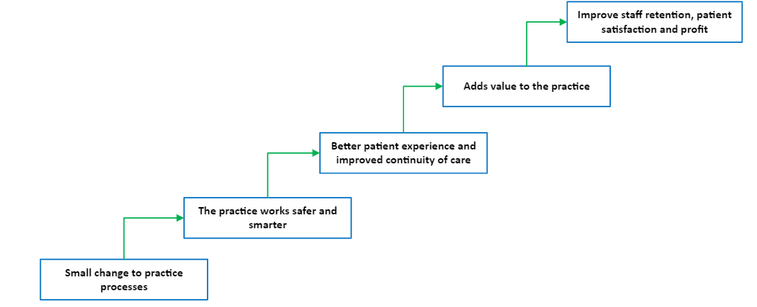

Payments Available
A collaboration between The Cancer Screening Unit of Queensland Health and Brisbane North PHN has made funding available for practices to undertake Continuous Quality Improvement (CQI) activities to increase cervical and bowel cancer screening rates. Using these funds, we will be able to provide payments to practices undertaking continuous quality improvement (CQI) activities in Cervical and Bowel Cancer Screening. The payment structure is outlined in the table below:

NUMBER OF CQI ACTIVITIES  BEING UNDERTAKEN | INITIAL  PAYMENT*  (Part 1 of the CQI Plan submitted) | COMPLETION PAYMENT*  (Part 2 of the CQI Plan submitted) | TOTAL PRACTICE PAYMENT*
1 Activity | $ 250 | $ 250 | $ 500
2 Activities | $ 250 | $ 500 | $ 750
3 Activities | $ 250 | $ 750 | $ 1 000
4 Activities | $ 250 | $1 000 | $ 1 250
* including GST

Things to note
- The payments are for undertaking the CQI activities, tracking and reporting on their progress. The completion payment is not subject to all activities having had a positive outcome (or even the intended outcome).

- Payments are for undertaking activities that build a practices capability and enhance patient outcomes or experience. Payment is not available for activities that are required under the RACGP accreditation standards.

The Process
- Practices can choose up to four Continuous Quality Improvement (CQI) activities from the list below (Table 1 - Focus Areas and suggested CQI activities). You can also develop practice-specific activities you think will improve the outcomes for your multicultural patient cohort. The Practice Development Matrix can help you to develop these activities

- To express interest the practice complete Part 1 of the Continuous Quality Improvement Plan paperwork and submit this to Brisbane North PHN (practicesupport@brisbanenorthphn.org.au) by 28 February 2025. This document will outline the:
  - Cancer Screening goals you want to achieve
  - Activities you will implement to achieve these goals
  - Timelines you are working to
  - How you are going to measure your progress.

- Brisbane North PHN will review your expression of interest and inform you if you have been successful.

- We will send you agreement paperwork to sign and return

- You send Brisbane North PHN an invoice for the initial payment of $250 which we will pay

- You work on your proposed activities with the support of your QI&D Engagement Officer between the period of February to April 2025

- To receive your completion payment, complete Part 2 of the Continuous Quality Improvement Plan paperwork and submit it to Brisbane North PHN by 30 April 2025 together with an invoice for your completion payment.

Focus Areas and Suggested Activities
Practices can choose up to four CQI activities from the list below. The activities can all come from the one focus area or from across several focus areas. What you choose to do should be determined by your current practice situation, your patient population and your practice goals and objectives. You may want to do other Multicultural Health activities which are not listed on the table below. The Practice Development Matrix can help you with devising practice-specific activities.
Table 1 – Focus Areas and Suggested CQI Activities
Focus Area | Suggested CQI Activities for Practices to Undertake | Resources
CIS Integration to the NCSR | - Link CIS to NCSR: Establish the linkage as a standalone CQI activity, ensuring practices can directly report on successful integration. | - Primary Care Onboarding Kit  - Enhancing Preventative Care: Insights from practice managers on integrating with the National Cancer Screening Register | National Cancer Screening Register  - NCSR Communications Toolkit
 | - Upskilling Staff on NCSR Use: Provide a training session explaining NCSR’s purpose, benefits, and data functions for patient tracking.
 | - Staff Resource Guide: Create a concise, in-practice resource on how to access and update NCSR data within the CIS.
Cervical Cancer Screening | - Ethnicity Recording Improvement: Run PIP QI & Accreditation reports monthly to identify and update patient ethnicity data. | - National Cervical Screening Program | Australian Government Department of Health and Aged Care  Resources for Providers:  - Providing cervical screening | Australian Government Department of Health and Aged Care  Resources for Patients:  - Getting a Cervical Screening Test | Australian Government Department of Health and Aged Care
 | - Visual Aids for Self-Collection: Place instructional posters on self-collection techniques in clinic consultation room, waiting room or bathrooms, encouraging eligible patients to ask about self-collection.
 | - Patient Identification via PIP QI Reports: Use Primary Sense to identify patients missing cervical screening and flag for follow-up.
 | - Recall and Reminder Processes: Implement a recall system, using Primary Sense and NCSR, to notify patients due for screening.
 | - Opportunistic Screening for Frontline Staff: Train reception and frontline staff on eligibility criteria, prompting screening discussions during patient interactions.
Bowel Cancer Screening | - Data Cleansing for Bowel Screening: Perform quarterly data cleansing to ensure eligible patients are correctly identified for bowel screening. | Resources for providers:  - Indigenous bowel screening resources for health professionals | Australian Government Department of Health and Aged Care  - National Bowel Cancer Screening Program – resources for people with low vision | Australian Government Department of Health and Aged Care  - National Bowel Cancer Screening Program – Clinical resources | Australian Government Department of Health and Aged Care  - National Bowel Cancer Screening Program Information booklet  Resources for patients:  - Resources for families and communities – Indigenous bowel screening | Australian Government Department of Health and Aged Care
 | - Patient Identification and Recall: Run the Primary Sense Bowel Cancer Screening report to identify eligible patients and send reminders.
 | - Recall and Reminder Process Enhancement: Refine recall/reminder protocols for eligible patients using Primary Sense and NCSR data.
 | - Upskilling Staff: Train staff on bowel screening eligibility and the importance of reminders, emphasising how to address patient questions.
 | - Visual Aids: Place posters in waiting areas and bathrooms encouraging eligible patients to ask about bowel screening

Support and assistance

Your QI&D Engagement officer can help you develop your goals, choose your activities and set your timeline. We also have a wide range of resources available to support you through this process.

Information is also available on our practice support website (www.practicesupport.org.au), via email practicesupport@brisbanenorthphn.org.au or via phone on 07 3490 3495.

