


Importing templates into clinical software

eReferral templates
- Best Practice
- Medical Director

DO NOT OPEN templates.
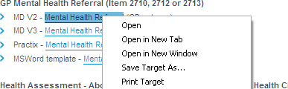
Right click on the template you require, then left click ‘Save Target As’. Save the template to a folder or to your desktop.

Best Practice

- When importing a file from a website, right click the mouse on the template you want, and then left click
Save Target As. Save the template to a folder or to your desktop.

- At the main start screen, open the Word Processor by clicking the icon that looks like a piece of paper.
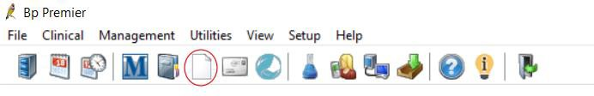

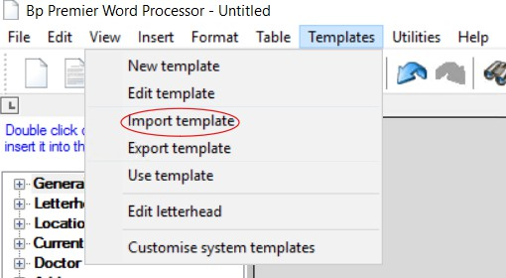
- Once in the Word Processor, from the main menu, select Templates, then Import Templates.

www.brisbanenorthphn.org.au
Level 1, Market Central
120 Chalk Street, Lutwyche QLD 4030
PO Box 845 Lutwyche QLD 4030
t 07 3630 7300

- Select folder or desktop where you saved the template and highlight the template. Click Open to import your template.
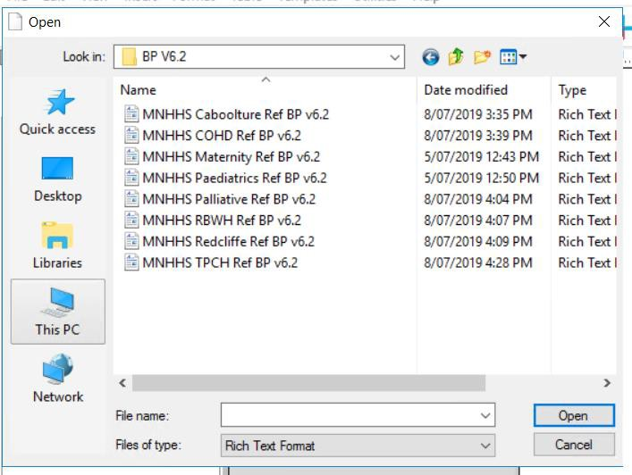

Now save your template, select the Save icon.
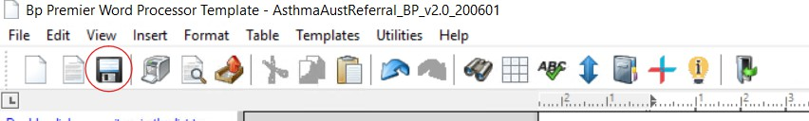
- Finally, name the template. Make sure you tick the Available to all users box to give access to all users.

If you leave it unticked, only you will have access to that template. Select save and the template is now ready to be used.
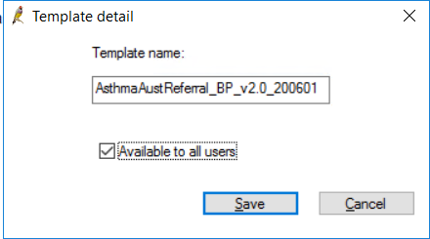

Medical Director

DO NOT OPEN templates.
Right click on the template you require, then left click ‘Save Target As’. Save the template to a folder or to your desktop.

Open Medical Director Letter writer via the main menu, pressing F8 or in a patient’s file.
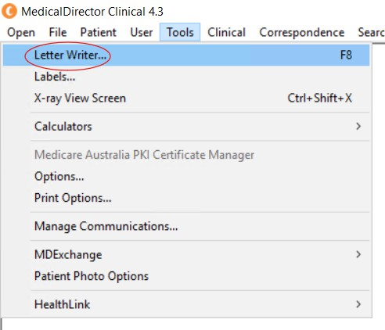
- From within Letter Writer select File > New. The New window appears
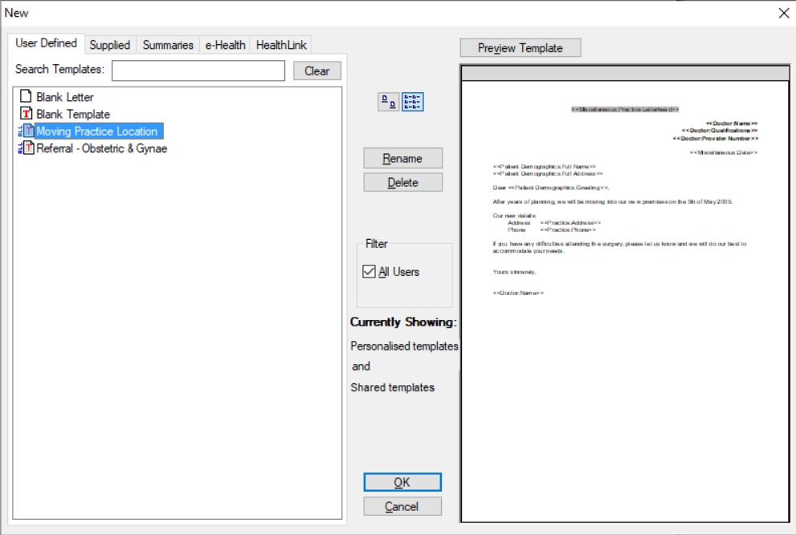

Select Blank Template and click OK A new blank document will open.

- Select File > Import.

Locate, select and open the file you wish to use as a template.

Whilst you can import documents of the types rtf, doc, htm, html, and txt and then save them as templates, if you want to import a Letter Writer template from another Medical Director Clinical user, the template must be in RTF format.

- Select File > Save as Template. The Save window appears.
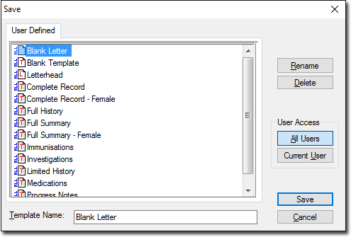

- Enter a name for the template and click Save The template is now ready for use.

