


Check the number of allied health service via Medicare App
- Download and sign into Medicare Express Pluss mobile App or sign in to Medicare via MyGov
- Go to ‘Menu’ and select ‘My Care Plans’
- Select ‘View history’. If multiple patients appear, choose the relevant name
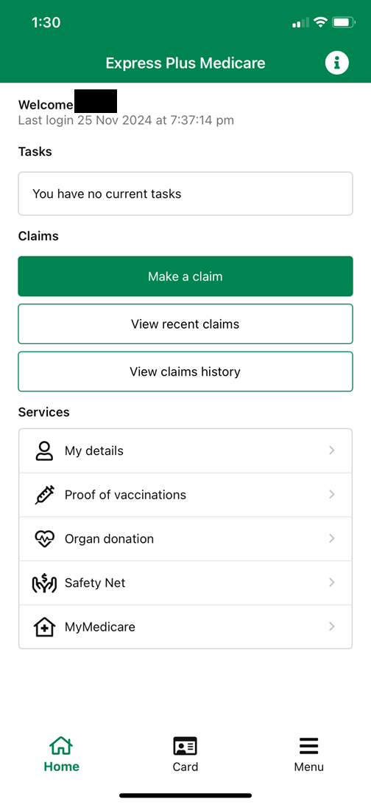
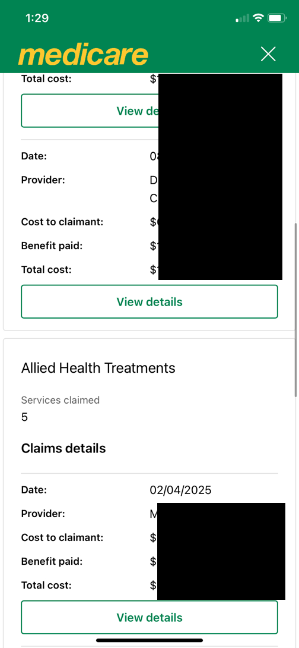
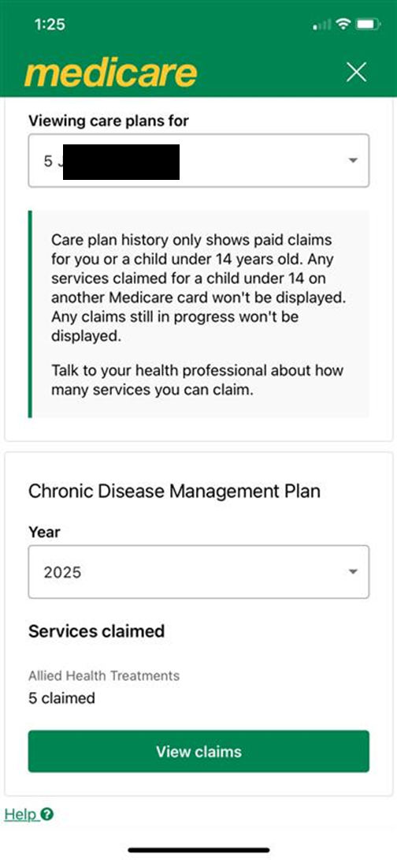
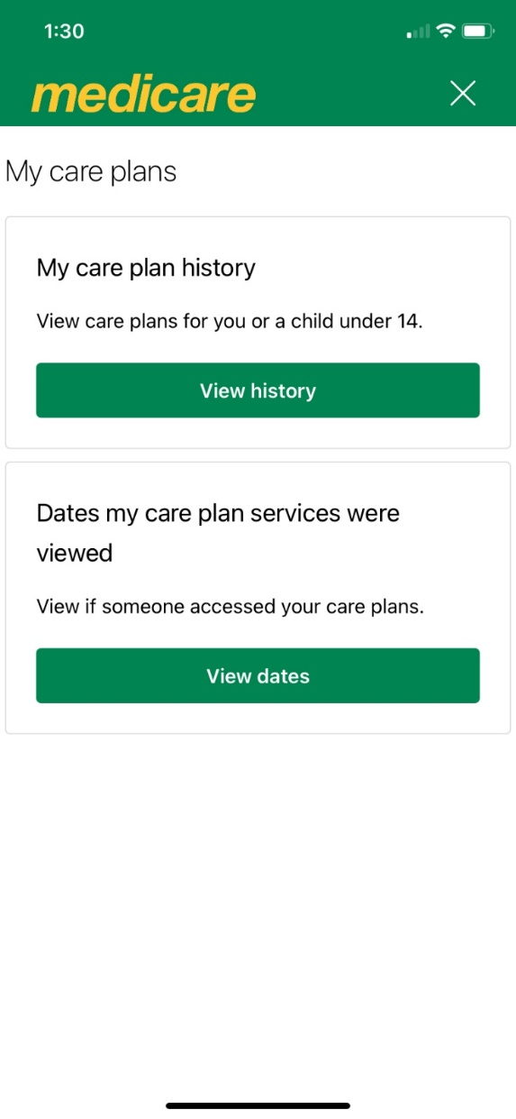
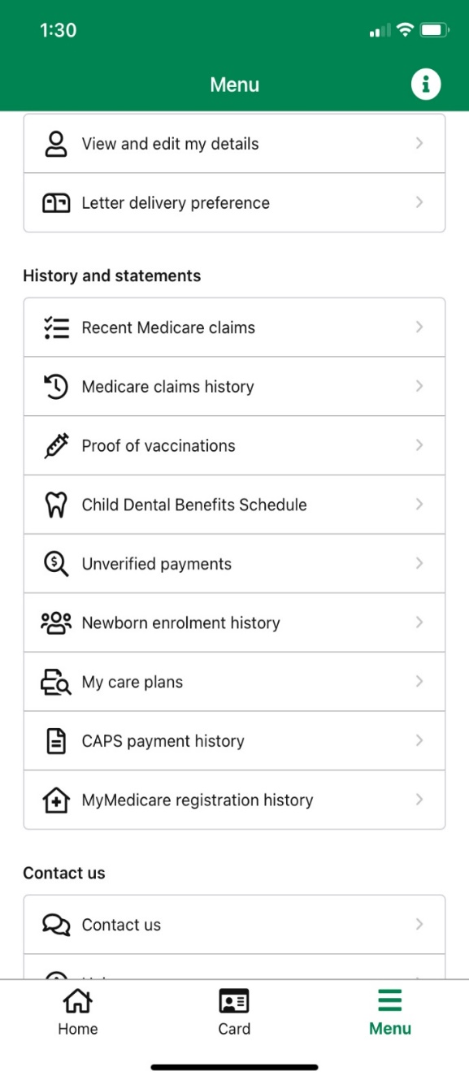

- View Service claimed, including the number of Allied health visits claimed and provider d
1.
4

3.

2.

Note: you can also download history (PDF) and when someone has accessed the care plans.

