BRISBANE NORTH PHN

Multicultural Health Practice Payments

1 October 2024 – 31 March 2025

Why Multicultural Health?
Australia has a diverse mix of cultural backgrounds and over 50% of the Australian population was born overseas or has one parent who was born oversea. People from multicultural backgrounds, particularly non-English speaking backgrounds, face a range of challenges including:

- Low English proficiency
- Adjustment to a new country
- Stresses of migration
- Trauma exposure prior to migration
- Loss of close family bond and sense of community
- Racism and discrimination
- Limited opportunities to fully utilise their occupational skills or lack of prior education recognition
- Ongoing media coverage of world events
People from multicultural backgrounds also often face barriers to accessing and navigating the Australian Health Care System through:

- Unfamiliar health systems
- Lack of interpreter access
- Insufficient support to navigate health service systems
- Low health literacy
- GP and health workforce shortages
- Cost of medical care and fewer medical practices bulk billing
- Limited access to transport

To enhance multicultural health outcomes Brisbane North PHN have identified five focus areas:

- Improving practice cultural awareness and competence
- Increasing Translating and Interpreting Service (TIS) familiarity and usage
- Improving Multicultural Data Collection
- Providing and promoting health resources in languages other than English
- Improving health outcomes for multicultural populations

Continuous Quality Improvement (CQI) Process
Continuous Quality Improvement (CQI) activities are actions designed to help practices work better, safer, and smarter. Ideally, CQI activities are small, incremental adjustments to existing processes that will result in long-term changes that add value to your practice.
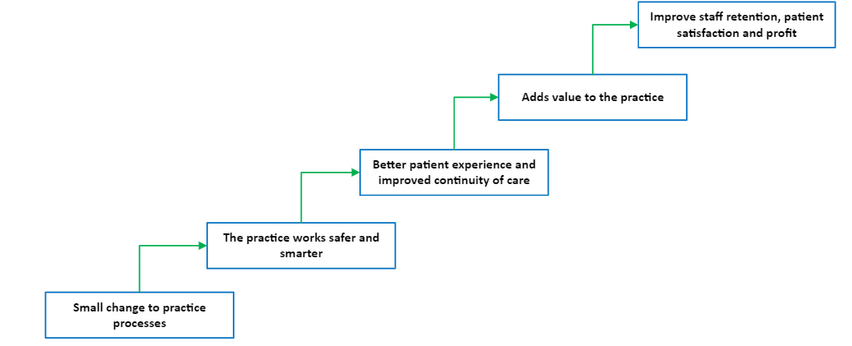

Payments Available
Funding has been made available for Multicultural Health Continuous Quality Improvement (CQI) activities this quarter under the Department of Health and Aged Care Multicultural Access Program. Using these funds, we will be able to provide payments to practices undertaking continuous quality improvement (CQI) activities in Multicultural Health. The payment structure is outlined in the table below:

NUMBER OF CQI ACTIVITIES  BEING UNDERTAKEN | INITIAL  PAYMENT  (Part 1 of the CQI Plan is submitted) | COMPLETION PAYMENT  (Part 2 of the CQI Plan is submitted) | TOTAL PRACTICE PAYMENT
1 Activity | $ 250 | $ 250 | $ 500
2 Activities | $ 250 | $ 500 | $ 750
3 Activities | $ 250 | $ 750 | $ 1 000
4 Activities | $ 250 | $1 000 | $ 1 250

Things to note
- The payments are for undertaking the CQI activities, tracking and reporting on their progress. The completion payment is not subject to all activities having had a positive outcome (or even the intended outcome).

- Payments are for undertaking activities that build a practices capability and enhance patient outcomes or experience. Payment is not available for activities that are required under the RACGP accreditation standards. An example – the initial enrolment in an interpreter service is an accreditation requirement and so is not an appropriate activity for a funded CQI activity. Training of staff in the use of interpreter services, advertising this service and other activities that embed the use of this service into practice processes are considered CQI activities and are eligible for funding.

The Process
- Practices can choose up to four Continuous Quality Improvement (CQI) activities from the list below (Table 1 - Focus Areas and suggested CQI activities). You can also develop practice-specific activities you think will improve the outcomes for your multicultural patient cohort. The Practice Development Matrix can help you to develop these activities

- To express interest the practice complete Part 1 of the Continuous Quality Improvement Plan paperwork and submit this to Brisbane North PHN (practicesupport@brisbanenorthphn.org.au). This document will outline the:
  - Multicultural health goals you want to achieve
  - Activities you will implement to achieve these goals
  - Timelines you are working to
  - How you are going to measure your progress.

- Brisbane North PHN will review your expression of interest and inform you if you have been successful.

- We will send you agreement paperwork to sign and return

- You send Brisbane North PHN an invoice for the initial payment of $250 which we will pay

- You work on your proposed activities with the support of your QI&D Engagement Officer between the period of October 2024 and March of 2025

- To receive your completion payment, complete Part 2 of the Continuous Quality Improvement Plan paperwork and submit it to Brisbane North PHN together with an invoice for your completion payment.

Focus Areas and Suggested Activities
Practices can choose up to four CQI activities from the list below. The activities can all come from the one focus area or from across several focus areas. What you choose to do should be determined by your current practice situation, your patient population and your practice goals and objectives. You may want to do other Multicultural Health activities which are not listed on the table below. The Practice Development Matrix can help you with devising practice-specific activities.
Table 1 – Focus Areas and Suggested CQI Activities
FOCUS AREA | SUGGESTED CQI ACTIVITIES | RESOURCES
1 - Improving practice cultural awareness and competence | Create a data profile of your patient population using  - Primary Sense  - Clinical and other software  - Brisbane City Council data  - Australian Bureau of Statistics data | - ABS Statistics by Region  - Brisbane City Council Population Profile Reports
 | - 1 reception/admin staff member doing CEH Cultural Competence online training course  - 1 clinical team members completing all 3 CEH online training course | CEH Online Learning  - Cultural Competence (2.5 hours)  - Health Literacy (1 hour)  - Trauma-Informed Care (1 hour)
 | - Promotion of translator and health services (TIS) in languages other than English. Undertake an information campaign – brochures, posters in waiting and consultation rooms and update practice website. Provide your new patient form in languages other than English.
- Multicultural health planning session/s to discuss your current capacity and capability and how you can improve health outcomes for CALD patients
- Practice-wide multicultural health goals developed and added to practices strategic plan
- Include multicultural health plans and processes in new staff induction, your policies and procedures manual and other practice documents
2 - Increasing Translating and Interpreting Service (TIS) familiarity and usage | - Information campaign for practice staff, GP’s and patients about Translating and Interpreting Service (TIS) and its use. Posters, brochures and information on practice website, add TIS to the induction for new staff and policy and procedure manual  - Training session for reception staff:  - How to add a new GP to TIS  - How to book a session  - Longer appointment times required for CALD patients  - Possibly need for a need series of appointments  - Encourage patients to come early for their first appointment to complete new patient paperwork | - Translating and Interpreting resources including posters, factsheet and interpreting guide (coming soon)
 | - Annotate patient records in the clinical software if an interpreter is required  - Record languages GP’s speak in APHRA, MyHealth Record (through Provider Connect) and your practice website  - Update GP information in TIS and circulate updated user details to all staff | - Translating and Interpreting resources including posters, factsheet and interpreting guide (coming soon)
 | - Training session for doctors:  - How to use TIS  - Who can/should interpret for your patient if you are not using TIS  - How to bill for the consultation time (given that extra communication time is needed)  - Building rapport building and trust | - Translating and Interpreting resources including posters, factsheet and interpreting guide (coming soon)  - Factsheet – Inclusion of communication time when claiming time tiered MBS items
3 - Multicultural data collection | - Education session for practice staff on why the recording of ethnicity in clinical software is important and how to collect this information in a culturally sensitive manner  - Information campaign on the importance of recording ethnicity. Posters in waiting rooms, consulting room, treatment room, brochures for patients, information on practice website | - IUIH’s training Sat 23/11/2024 8.30 – 4pm. Audit, training and 5 CPD hours
 | - Data cleansing activity  - Use primary sense “Patients booked in the next 2 weeks with missing PIP QI report” to see which patients do not have ethnicity recorded.  - Improve recording of ethnicity, preferred language, country of birth and if an interpreter is required (and year of arrival in Medical Director) percentages  - Update new patient registration form to include new ethnicity data fields. Implement a process to update existing patient information via paper form, email, booking/appointment software or check-in kiosk  - Create a checklist of data to update/check on patient arrival for reception staff | - Translating and Interpreting resources including posters, factsheet and interpreting guide (coming soon)
4 - Providing health resources in languages other than English | - Instruction cards for key procedures in languages other than English laminated and in doctors rooms (cervical self-collection, bowel screening, prostate check, blood and urine collection, vaccinations)  - Health literacy resources (e.g. brochures, posters, videos, consent forms) available in languages other than English  - Add an information session about resources in other languages  - Promote available resources to patients through brochures, signage and practice website | - Health Translations Library healthtranslations.vic.gov.au  - Practice support website  - Refugee Health Queensland Translated Resources  - Qld Health Vaccination resources in languages other than English  - FindCareFast – Health Navigation Website for bilingual health providers – being launched in November 2024
5 - Improving health outcomes for multicultural populations | - Signage about fees, if the practice bulk-bills and after hours care in languages other than English  - Staff learning session about available health services, medicare access and referral pathways for patients from CALD backgrounds  - Audit appointment follow up and recall and reminder processes. Letters and phone messages can be confusing for CALD populations. Check SMS messages and documents are clear and consider language differences. Consider using the online appointment translation | - Australian Refugee Health Practice Guide  - My Health 4 Life  - HealthPathways - Brisbane North PHN  - Refugee Health Clinical Advisory Group  - Partnership advisory group  - NSW Health Online appointment Translation tool
 | - Training and information session for GP’s on programs available to support and assist refugees and survivors of torture and trauma | - Forum of Australian Services for Survivors of Torture and Trauma
 | - Identify and recall patients who are eligible for a Refugee Health Assessment (MBS Item 224, 225, 226, 227, 701, 703, 705, 707) | - Recommendations for Comprehensive Post Arrival Health Assessment for people from Refugee Like Backgrounds  - Refugee Health Practice Guide
 | - Identify and recall CALD patients with complex care needs. Check care plans, management plans and vaccinations are up to date. | - NDIS  - MyAgedCare  - HealthPathways - Brisbane North PHN
 | - Check the vaccination status of CALD patients and recall for catch-up vaccines through Qld Health Immunisation Program | - Queensland Health Immunisation Program

Support and assistance

Your QI&D Engagement officer can help you develop your goals, choose your activities and set your timeline. We also have a wide range of resources available to support you through this process.

Information is also available on our practice support website (www.practicesupport.org.au), via email practicesupport@brisbanenorthphn.org.au or via phone on 07 3490 3495.

