Your Guide to Practice Catalyst

Purpose of this guide
This guide introduces general practices to the Practice Catalyst tool and explains how to interpret their results once they have received their Practice Catalyst Action Plan. It outlines what the tool measures, how it supports practice improvement, and how each of the five domains reflects a key element of high-performing general practice. The guide is designed to help practice teams use Practice Catalyst as a practical resource for reflection, planning, and continuous improvement. supported by Brisbane North Primary Health Network.

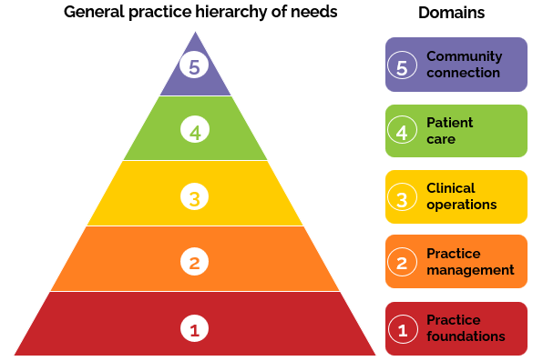
About Practice Catalyst

What is Practice Catalyst?
Practice Catalyst is a self-assessment and improvement tool that helps general practices understand their current strengths and identify opportunities for growth. The tool contains one self-assessment that considers both practice maturity and sustainability.
Practice maturity
The self-assessment asks you to provide information about how the team members in your practice organise themselves, use tools and work together. This is referred to as practice maturity.
This component of the assessment focuses on five domains that together describe a sustainable, high-quality, and well-connected general practice:
- Practice Foundations
Rebbeck’s General Practice Hierarchy of Needs Framework
- Practice management
- Clinical operations
- Patient care
- Community connection
Each domain includes questions and examples that help practices reflect on their systems, processes, and culture.

Practice sustainability
Practice Catalyst also looks at how your practice is doing compared to others in your region to help identify ways to strengthen your long-term sustainability.
This part of the assessment considers the following sub-domains and indicators:
Sub-domain | Example indicators
Workforce | Workforce size and stability, leadership resilience and succession planning, recruitment and retention
Financial | Billing approach, revenue diversification, optimisation of funding, and accreditation status.
Infrastructure | Fit-for-purpose premises and affordability, digital systems
Access & Continuity | Appointment wait-times, patient book status, and business and service continuity planning
Your responses will place you into a sustainability category, which shows how your practice compares with others in the region.
This category is not a prediction or diagnosis. Instead, it’s a guide to help highlight areas that may need extra support or a closer look to strengthen your practice’s sustainability.
All information collected through Practice Catalyst is aggregated and used to support regional planning and quality-improvement programs. Data is not shared outside the PHN or used for funding or grant decisions without the practice’s consent.
Practice Catalyst Action Plan
After completing the survey, each practice receives a tailored Action Plan outlining priority actions and practical resources to support improvement over time.
Evidence base
Practice Catalyst was designed by Rebbeck, drawing on extensive national and international evidence of what makes general practice effective, sustainable, and patient-centred. Internationally, it reflects models of high-performing primary care that emphasise leadership, teamwork, data-driven improvement, and system integration. Nationally, it aligns with the RACGP Standards for general practices (5th edition), PHN quality improvement frameworks, and Australian studies on sustainability, access, equity, and outcomes. This evidence base was complemented by insights from national PHN practice support programs.

The Brisbane North Primary Health Network has worked in partnership with Rebbeck to adapt and contextualise the framework for general practices across Brisbane North, ensuring it reflects local realities while remaining relevant and applicable to practices across Australia.

Understanding each domain

Domain 1: Practice Foundations
The practice foundations domain considers how well a practice is positioned to remain viable, adaptable, and resilient over time. A practice with strong foundations maintains stability through strong leadership, effective financial management, and strategic planning for workforce, facilities, and emergencies. It uses data to guide decisions, diversifies income streams, and maintains accreditation to ensure long-term quality and resilience.
Sustainability is most often tested when recruitment is difficult, systems are outdated, or financial oversight is limited - but proactive planning helps maintain confidence and continuity.

Domain 2: Practice management
The practice management domain considers how a practice is led, organised, and continuously improved. Effective practice management combines clear leadership, open communication, and a culture that values staff wellbeing and learning.
Strong management systems ensure that strategies align with patient and community needs, supported by data, digital tools, and transparent decision-making. Challenges usually occur when planning time is limited, systems are inconsistent, or data is collected but not applied - yet strong leadership and structure help teams stay cohesive and adaptable.

Domain 3: Clinical operations
The clinical operations domain considers the systems, governance, and workflows that underpin safe, high-quality, and efficient care.
Strong clinical operations are supported by sound governance, ongoing professional development, and digital integration.
Practices that coordinate care across settings, follow evidence-based pathways, and use telehealth and analytics as part of everyday work can anticipate patient needs and improve outcomes. Gaps often arise when technology is underused or time for improvement is scarce, but consistent processes strengthen care quality and reliability.

Domain 4: Patient care
The patient care domain considers how practices deliver care that is person-centred, continuous, and culturally safe. High-quality patient care builds trust through strong relationships, clear communication, and equitable access.
Practices that engage patients in decisions, provide education and self-management support, and use digital tools to enhance access and follow-up deliver more responsive and effective care. Continuity can be disrupted by workforce changes or unaddressed feedback, but an ongoing focus on relationships and accessibility maintains dependability and confidence.

Domain 5: Community connection
The community connection domain considers how practices engage with their communities and contribute to population health. Community-connected practices work with PHNs, hospitals, and local organisations to identify needs, reach underserved populations, and co-design services that improve equity and access.
By using local health data, participating in health promotion, and maintaining partnerships, practices strengthen trust and relevance.
Although engagement takes time and resources, it plays a vital role in long-term community wellbeing and in aligning local health services with real-world needs.

Using your results
Your Practice Catalyst results show how your practice is performing across each domain and include tailored recommendations for improvement.
Each recommended action links to trusted resources that can help your team make practical changes and track progress over time.
Your PHN’s Primary Care Facilitators can help you:
- Interpret your results and identify priority areas.
- Connect with training, peer learning, or improvement programs.
- Access tools and resources that match your practice’s needs and goals.
Practice Catalyst is not an audit or compliance tool - it is a starting point for reflection, learning, and action to strengthen general practice now and into the future.
Intellectual property
The Practice Catalyst framework and supporting materials are proprietary to Rebbeck Pty Ltd and may not be reproduced, adapted, or redistributed without written permission.

